**24.Type of website**

**Exercise**

* **Write a program to find out the type of website from the URL:**
* **.com – commercial website**
* **.org – organization website**
* **.in – Indian website**

**Approach:**

**So here we did like this**

**Java : The Java String class endsWith() method checks if this string ends with a given suffix. It returns true if this string ends with the given suffix; else returns false.**

**Python : Same like Java, we’re using endswith() method in python as well**

**Solution 👇**

**Java :**

**import java.util.Scanner;**

**public class CodeXam {**

**public static void main(String[] args)**

**{**

**Scanner sc = new Scanner(System.in);**

**System.out.println("Enter Your Website: ");**

**String website = sc.next();**

**if(website.endsWith(".org")){**

**System.out.println("This is an Organizational website");**

**}**

**else if(website.endsWith(".com")){**

**System.out.println("This is a Commercial website");**

**}**

**else if(website.endsWith(".in")){**

**System.out.println("This is an Indian website");**

**}**

**}**

**}**

**output:**

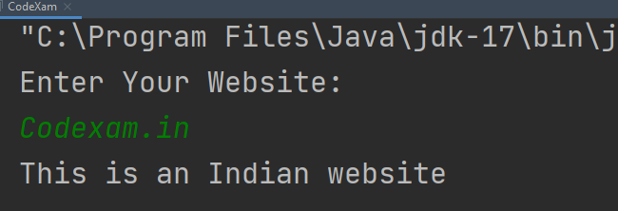

**Python :**

**user_input = input("Please Enter Your URL:\n")**

**if user_input.endswith(".com"):**

**print("It's an Commercial Website")**

**elif user_input.endswith(".org"):**

**print("It's an Organization Website")**

**elif user_input.endswith(".in"):**

**print("It's an Indian Website")**

**else:**

**print("Not Found !")**

**output:**

